**PERSONAL PROFILE K.Sreenivasulu** 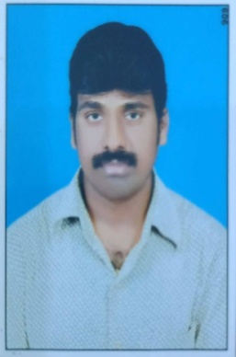

**M.Sc., B.Ed.**

**Lecturer in Zoology**

**Govt.Degree College**

**Porumamilla,Kadapa Dist**

**A.P, INDIA 516502**

**Contact number : +918019970990 (Mobile)**

**E.mail:** [**kcsubbarayudu@gmail.com**](mailto:kcsubbarayudu@gmail.com)

**PERSONAL PROFILE**

**Name : K.Sreenivasulu**

**Father Name : K.Subbarayudu**

**Date of birth : 01-01-1970**

**Religion : Hindu**

**Nationality : India**

**PERMANENT ADDRESS : K.Sreenivasulu**

**5/150B AST Street**

**Jammalamadugu**

**Kadapa(Dist), A.P, India.**

**ACADEMIC PROFILE**

|  |  |  |  |  |
| --- | --- | --- | --- | --- |
| **Course** | **Subjects** | **University/Board** | **% Of Marks** | **Year Of Passing** |
| **M.Sc** | **Zoology** | **S.V. University,**  **Tirupathi** | **64.4** | **1994** |
| **B.Ed** | **Biology, English** | **SK University,**  **Anathapur** | **59** | **1995** |
| **B.Sc** | **BZC** | **SK University,**  **Anathapur** | **60** | **1991** |
| **Intermediate** | **Botany,Zoology, Physics,Chemistry** | **Board Of Intermediate** | **61** | **1988** |
| **SSC** |  | **Board Of SSC** | **60** | **1985** |

**Attended Conferences/Seminars/Webinars/ToT**

|  |  |  |  |  |
| --- | --- | --- | --- | --- |
| **S.No** | **Name of the**  **Conferences/Seminars/**  **Webinars/ToT** | **Organized by** | **International/**  **national**  **university/state** | **Period** |
| **1** | **A Five day FDP In Zoology** | **CCE**  **A.P** | **State** | **06-06-2020 -**  **10-06-2020** |
| **2** | **Dairy technology –content delivery and**  **Assessment methods** | **CCE**  **A.P** | **State** | **10-08-2022 -**  **14-08-2022** |
| **3** | **Poultry** | **CCE**  **A.P** | **State** | **12-10-2022 -**  **16-10-2022** |
| **4** | **Tot On Internship And**  **LMS** | **CCE**  **GDC For MEN (A), Kadapa**  **AP** | **State** | **05-01-2023 -**  **07-01-2023** |
| **5** | **Tot On English medium of instruction, proficiency** | **CCE**  **GDC For MEN (A), Kadapa**  **AP** | **State** | **05-06-2023 -**  **10-06-2023** |
| **6** | **National Conference On Novel Materials For Sustainable Development** | **Dept. of Physics**  **GDC , Porumamilla, Kadapa** | **National** | **15-03-2024 -**  **16-03-2024** |